**Day 62 DIY Solution**

1. **Fetch data of all restaurants from MongoDB cloud database using Express and implement it in MVC architecture.**

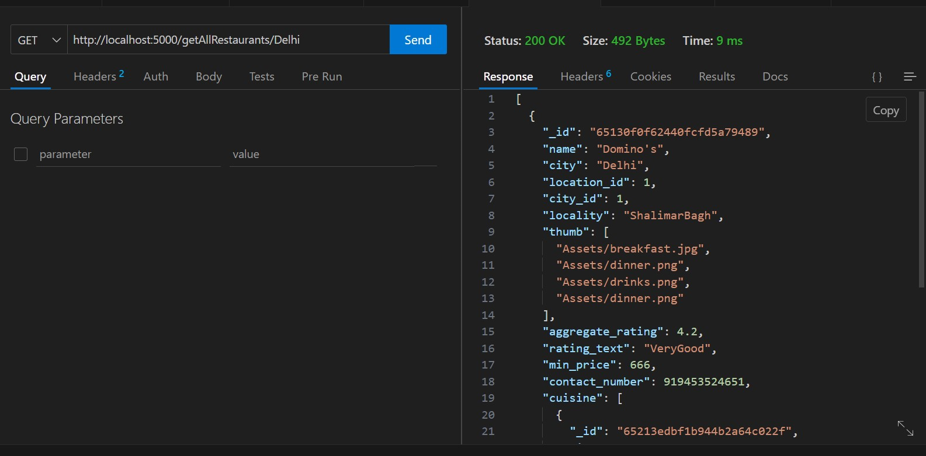

1. **Fetch data of all locations from MongoDB cloud database using Express and implement it in MVC architecture.**

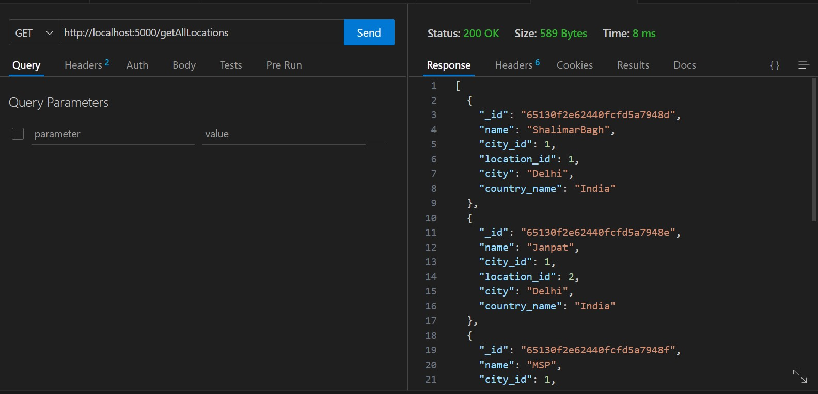

1. **Fetch data of all meal types from MongoDB Cloud instance using Express and implement it in MVC architecture.**

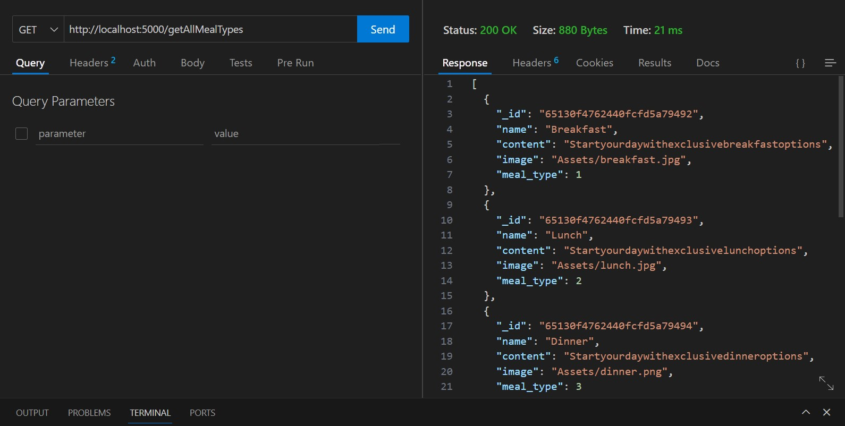

1. **Parameterized APIs: Create an API to filter the restaurants on city param and restaurant id param.**

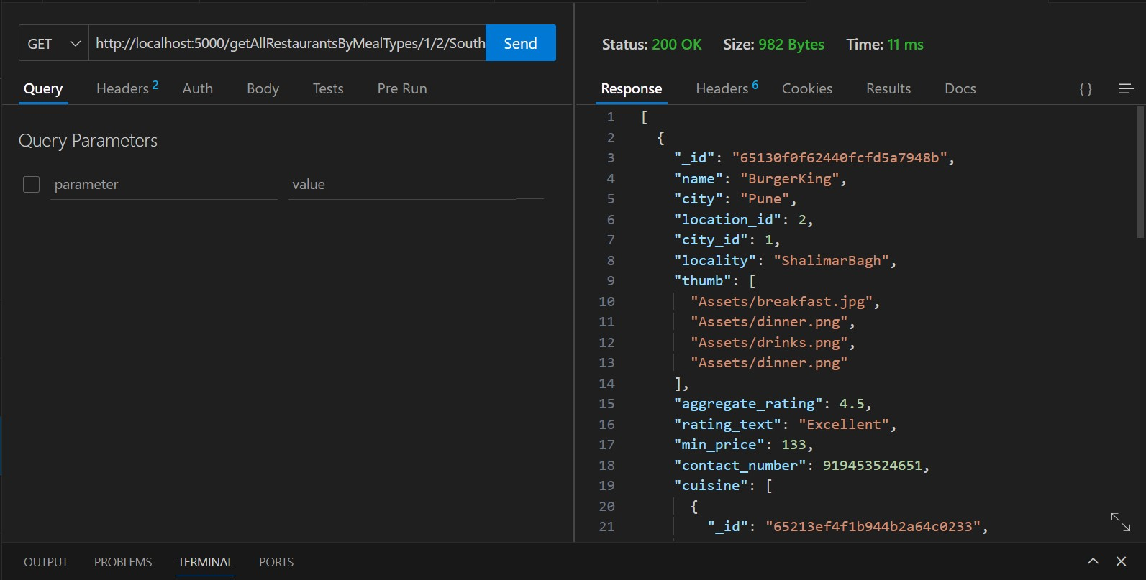

1. **Create an API to fetch the restaurants based on meal type, location, cuisine, low cost, high cost, sort, and the page number.**

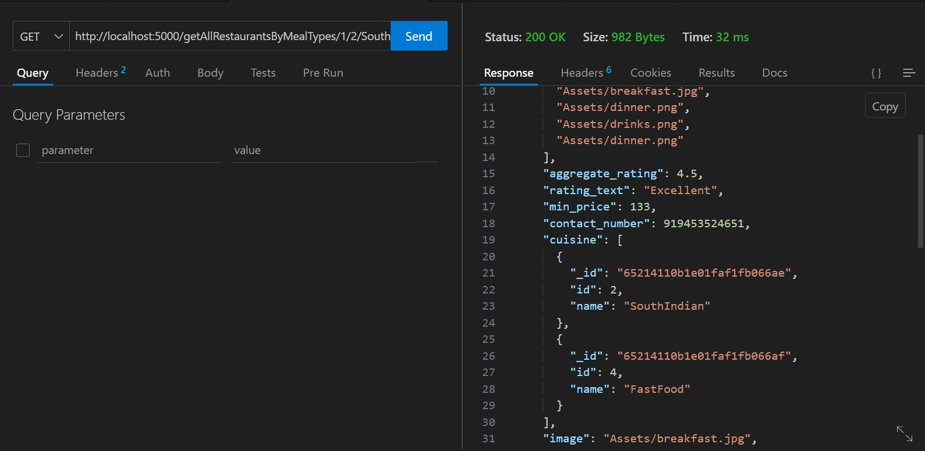

1. **Create an API for user Log on and Sign in functionalities?**

